**CLOUD COMPUTING DAY-3 QUESTIONS**

**USING AZURE**

**20. Create a SQL storage service and perform a basic query using any Public Cloud**

**Service Provider (Azure/GCP/AWS) to demonstrate Database as a Service (DaaS) Procedure:**

1.To open sql databases.

After setup sql databases and to go security.

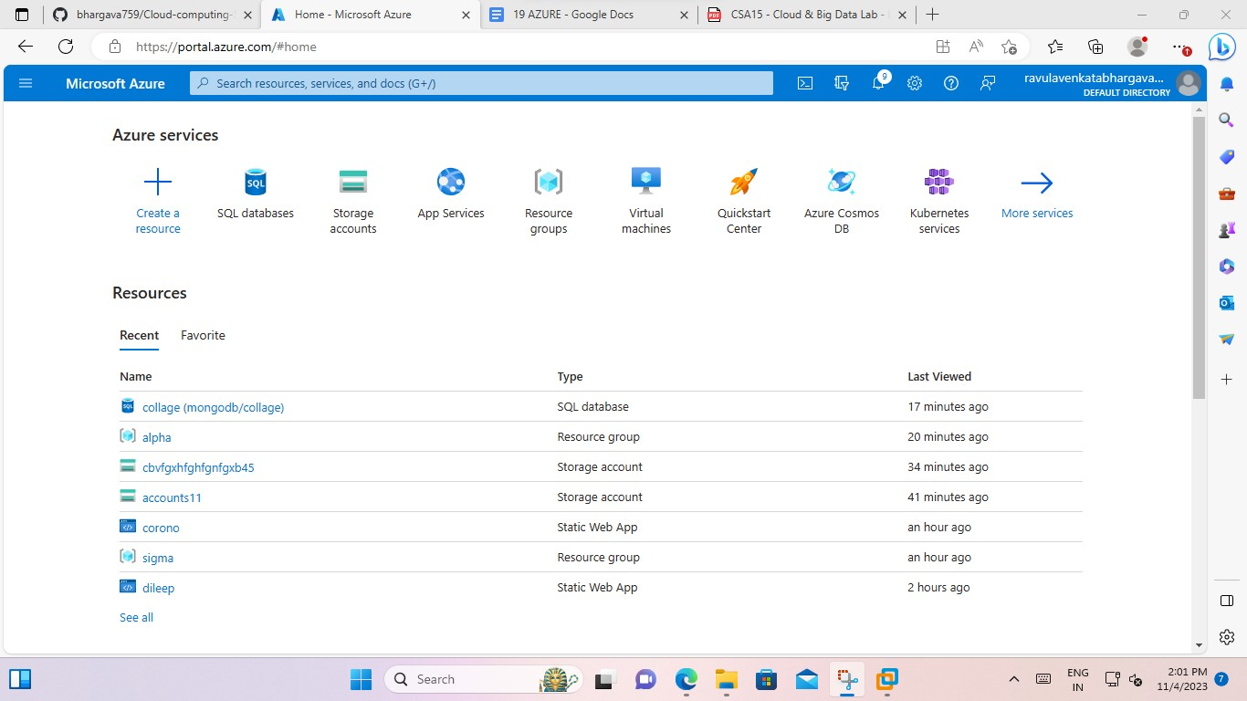

2.and create an sql databases.

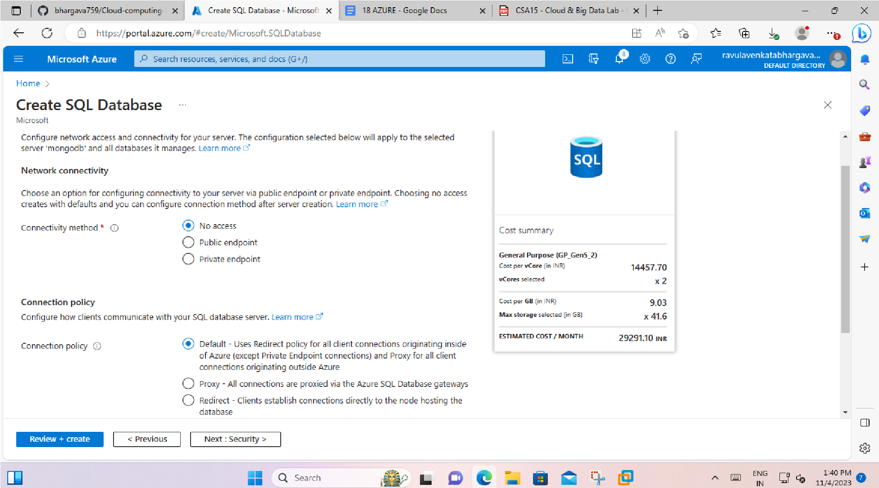-> to setup the sql databases. And also go to additional settings.

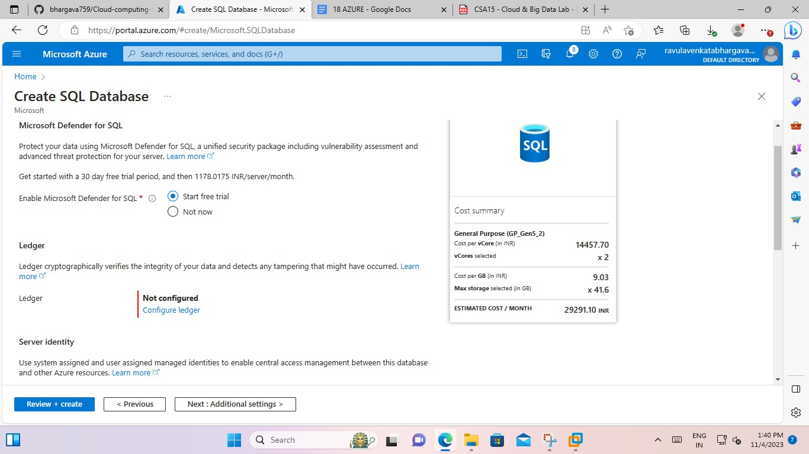

->additional settings.

->and after tags and give some names. And after review+text.

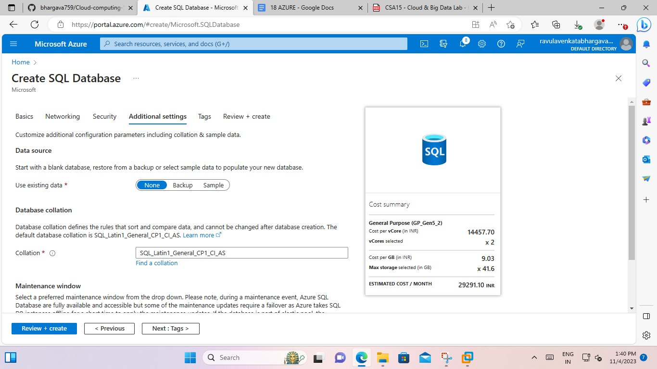

->

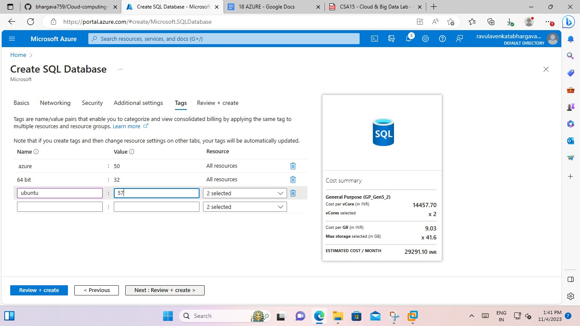

->after completion to create button should tap.

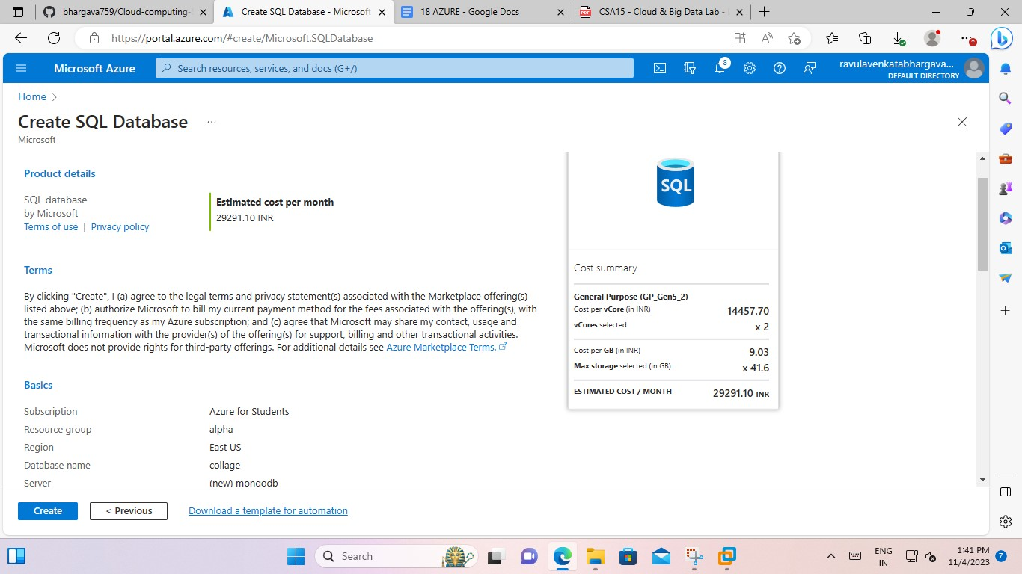

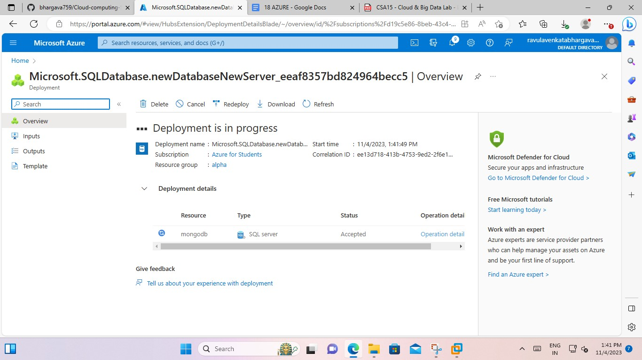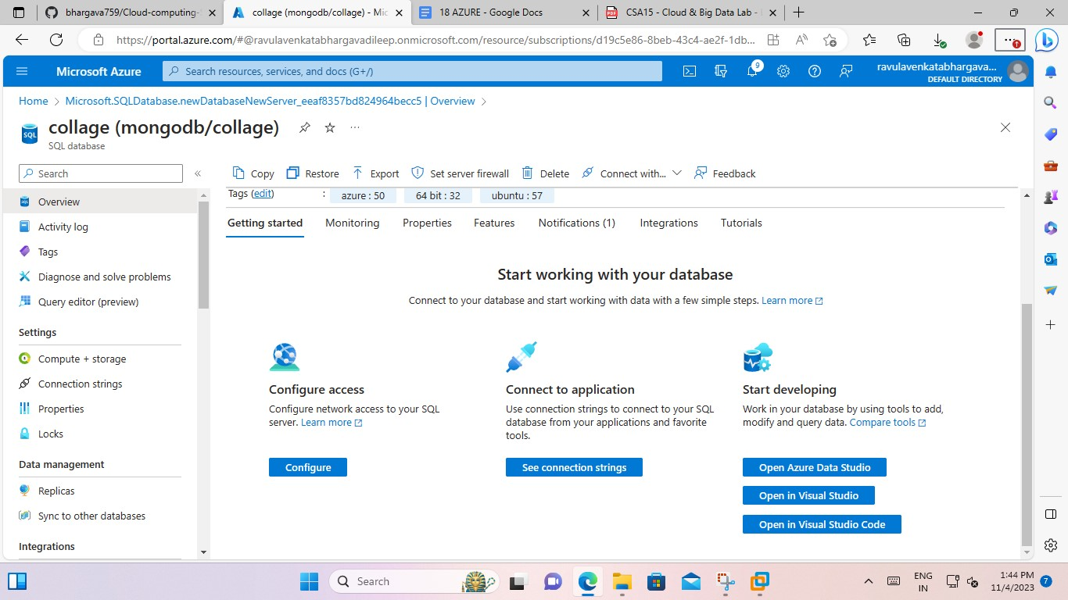

This is the method of working process databases.